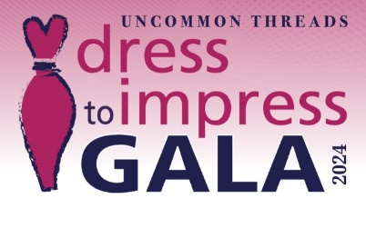
2024 SPONSORSHIP FORM

Please complete this form and mail it, along with your check (payable to Uncommon Threads) to:

Uncommon Threads
60 Island Street, Suite 150
Lawrence, MA 01840

If you have any questions, please contact: admin@uncommonsthreads.org or call us at 978.219.9559.

Business Name: __________________________________________________
Contact Name: ___________________________________________________
Phone: __________________________________________________________
Email: ___________________________________________________________
Address: _________________________________________________________
City: _________________________________ State: ______ Zip: ___________
Business website URL: _______________________________________________
Sponsorship Name: __________________________________________________
Amount Enclosed $______________
Signed: _________________________________________ Date: ____________
Thank you for supporting Uncommon Threads!

